Carlos Rosario School Document Guide for Enrollment

There are two methods to prove proof of residency in DC for enrollment at Carlos Rosario School programs. The guidelines for approval are determined by eligibility by OSSE. For any questions on eligibility, please contact registration@carlosrosario.org or call 202-797-4700.

All documentation must have the same name and address.

METHOD A: One ORIGINAL Document from the following list:

You only need to provide, A, B, C, or D, but they must meet all criteria in the right column.

Document Type | Document must include (please make sure every box is checked)
- Pay Stub | - MUST include DC tax withholding only, and no other states (Maryland and Virginia are NOT accepted)  - Tax withholding amount MUST include a tax deduction amount  - Must be dated within the past 45 days, any older will NOT be accepted
- Unexpired letter confirming financial assistance issued by DC Government  Example: TANF, Medicaid, DC Alliance, Supplemental Security Income | - Document must confirm assistance from DC Government  - The letter must be unexpired and current  - Insurance Card is NOT accepted, you must bring your approval benefit letter.  - If you receive this benefit, but do not have a letter, you must contact the DC office of Health Care at (202)-724-7491 to receive a copy of your letter.
- Certified copy of Tax Form D40  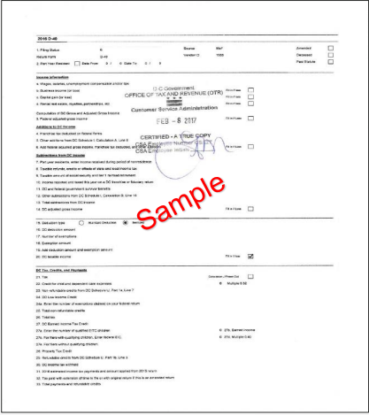 | - Must be a certified copy issued by DC Office of Tax and Revenue  - Must have evidence of payment of DC taxes for the current or most recent  - tax year  - DC income tax withheld Line 31 in the form MUST have a value greater than $0
- Embassy Letter proving that the applicant resides on embassy property or will reside on DC property confirmed by the embassy | - Must be on embassy letterhead and include official embassy seal  - Must confirm that the student lives in the property or the embassy.  - Must be issued within the past 12 months  - Must have a signature of an official embassy employee

METHOD B: TWO ORIGINAL Documents from the following list:

Please provide two documents from the left column that meet all criteria in the right column.

Document Type | Document must include (please make sure every box is checked)
- Unexpired DC motor vehicle registration | - Name and address must match other documents from method B.  - Must be a physical copy or DC DMV digital copy can be shown (from app)  - Temporary registration is not accepted, must be an official copy of permanent registration
- Unexpired rental agreement or lease, and receipt for rent payment | - Name and address must match other documents from method B.  - You must be listed as a leaseholder  - Lease cannot be expired and must be current  - If the lease is expired, an official addendum may be added  - Amount of rent payment on the receipt must match lease  - The receipt must be an official receipt for rent  - Bank statements are accepted, but they must indicate rent and be an official payment to rental company  - Venmo, Zelle, or cash payment apps, handwritten notes are not accepted as a receipt.
- Unexpired DC driver license or DC official photo identification | - Name and address must match other documents from method B.  - Must be issued by DMV.  - License cannot be expired  - Temporary IDs/Driver License are accepted, but the student must submit a copy of official ID/permanent license once issued by DMV.
- One utility bill and one receipt of payment (only gas, electric and water bills are accepted. Cell phone and internet bills are not accepted) | - Name and address must match other documents from method B.  - Receipt of payment must be from past two months  - Bank statements are accepted, but they must indicate payment of utility bill.  - Venmo, Zelle, or cash payment apps, handwritten notes are not accepted as a receipt.

